Title: **One-Shot Solutions** Handout: 9

Course: Introduction to Automation Unit: Introduction of PLC CLO: 4

**Objectives**

1. Student shall develop a knowledge of one pushbutton solutions.

**Solution 1**

This solution uses a counter’s LSB to enable/disable a circuit

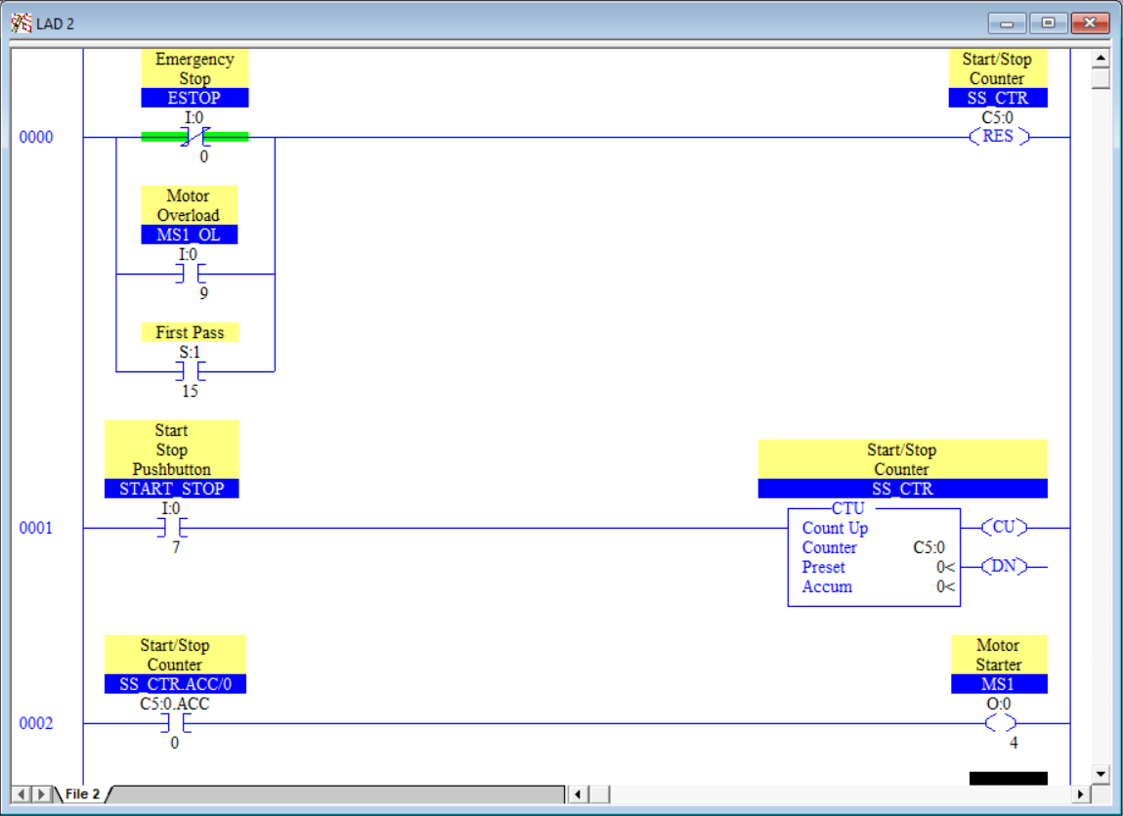

**Solution 2**

This solution uses internal memory bits and rung execution order to enable/disable a circuit.

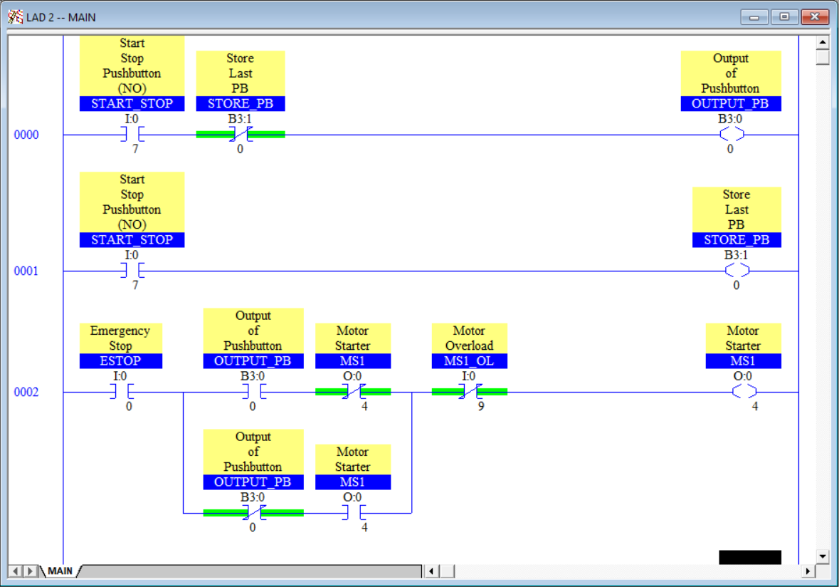

**Solution 3**

This solution uses a one-shot rising with the latch and unlatch output instructions.

